Machine Learning Model Deployment with IBM Cloud Watson Studio

**Phase 5: Project Documentation & Submission**

Problem Definition:

The problem you are addressing is the deployment of machine learning models using IBM Watson Studio on the IBM Cloud. Deploying machine learning models can be a complex task, involving multiple steps such as model training, evaluation, packaging, and serving. IBM Watson Studio offers a platform for data scientists and developers to collaboratively build and deploy machine learning models, but it requires effective design and implementation to ensure successful model deployment. Designing a machine learning model deployment with IBM Cloud Watson Studio can be applied to various real-time problems across different domains. Let's consider a specific real-time problem scenario and outline the steps involved in designing a solution for it.

Real-Time Problem Scenario: Predictive Maintenance for Industrial Equipment

Problem Description: In an industrial setting, there is a need to minimize downtime and reduce maintenance costs for critical machinery. Predictive maintenance can be used to proactively identify and address equipment failures before they occur. The goal is to design a machine learning model deployment solution to predict equipment failures in real-time.

Solution Design Steps:

Problem Definition and Data Collection: Identify the critical industrial equipment to monitor and maintain. Collect historical data from sensors and monitoring devices on these machines. This data may include temperature, pressure, vibration, and other relevant parameters. Define the criteria for equipment failure or degradation. For example, a machine is considered to have failed if certain parameters exceed predefined thresholds. Data Preprocessing: Clean and preprocess the collected data. Handle missing values, outliers, and noise. Engineer features that are relevant to predicting equipment failures, such as rolling averages, standard deviations, and trend analysis

**INNOVATION DESIGN TO SOLVE THE PROBLEM**

Deploying a machine learning model with IBM Cloud Watson Studio to solve a specific problem involves several steps. Let's go through a detailed, step-by-step process with a focus on design and innovation:

**Step 1: Problem Definition and Ideation**

* Define the specific problem you want to address with machine learning. For example, let's say you want to predict customer churn for a subscription-based tech support service.
* Identify the relevant data sources and the problem's context.
* Brainstorm innovative ways in which machine learning can address this problem, such as using advanced predictive modeling techniques.

**Step 2: Data Collection and Preprocessing**

* Gather relevant data from various sources. This might include customer profiles, support interactions, and historical churn data.
* Clean and preprocess the data. This includes handling missing values, encoding categorical variables, and scaling numerical features.

**Step 3: Feature Engineering and Selection**

* Engineer relevant features that can improve the model's predictive power. This may involve creating new variables, aggregating data, or transforming existing features.
* Use domain knowledge to select the most informative features.

**Step 4: Model Selection and Training**

* Choose the appropriate machine learning algorithms or models for your problem. For predicting churn, you might consider using classification models like logistic regression, decision trees, or ensemble methods.
* Train and validate multiple models to find the one with the best performance. Experiment with hyperparameter tuning and cross-validation.

**Integration with Other IBM Cloud Services:**

* Watson Studio seamlessly integrates with other IBM Cloud services, including data storage, databases, and cloud functions.

Now we are going to create the machine learning model with Watson Studio for that we will do the primary steps now :

**STEP1:**

* Login To The IBM account and click on the Catalog and then search for Watson Studio and give enter.
* You will get the Watson Assistant There By default you will have this

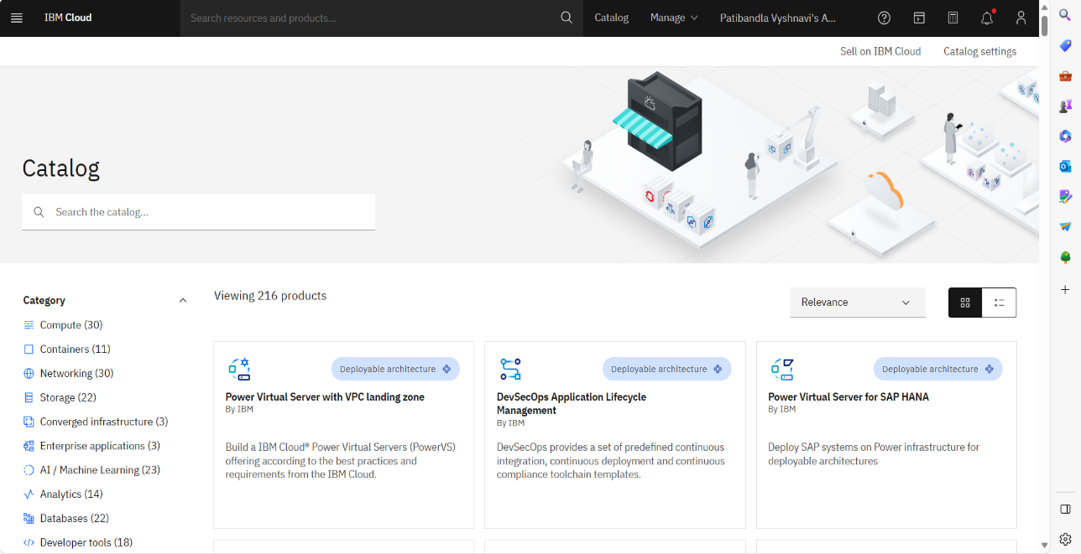

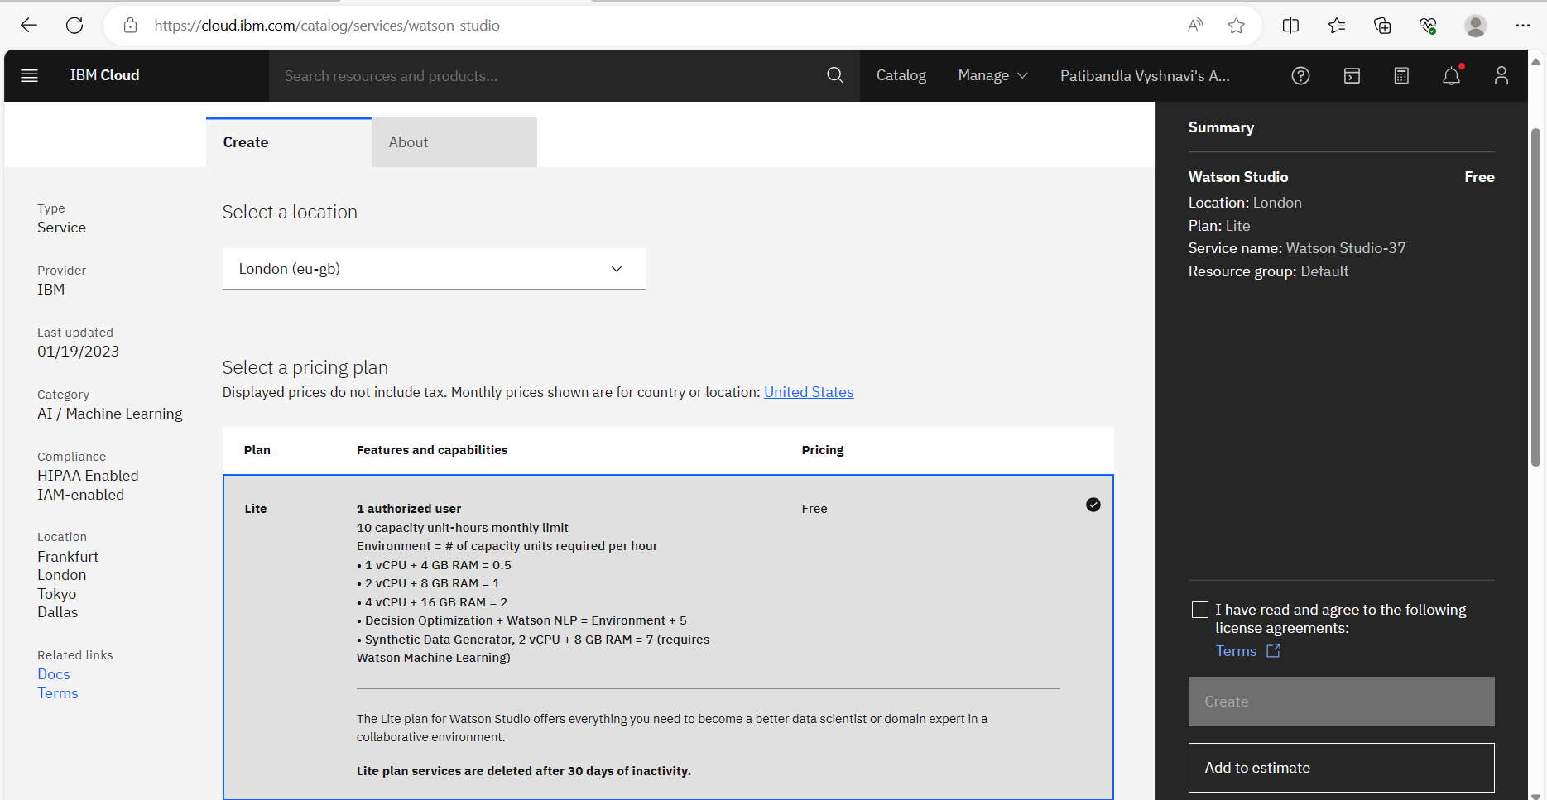

**STEP 2:**

* Change the default location and give the location as London(eu-gb) and select the plan as Lite
* Give tick mark for I Have read and agree to the following license agreement
* Now click on create it will create an instance for you

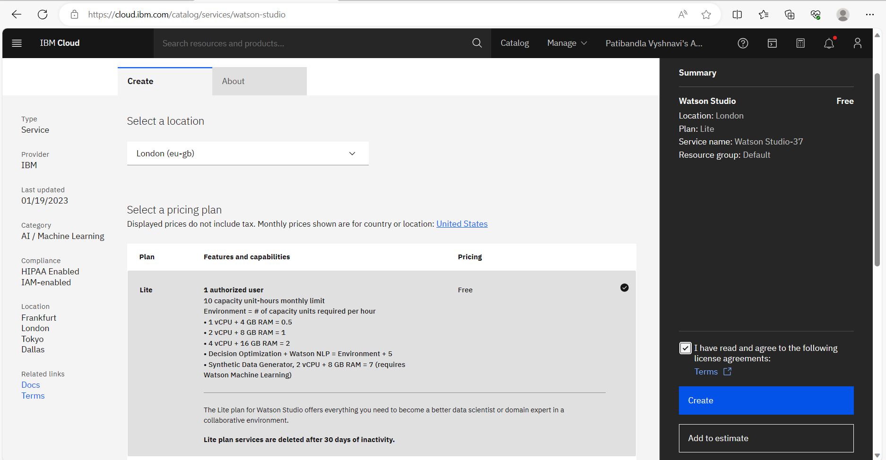

Step 3 :

* After creating an instance for Watson Studio you need to launch the Watson Studio by clicking the launch the IBM Cloud Pak for Data

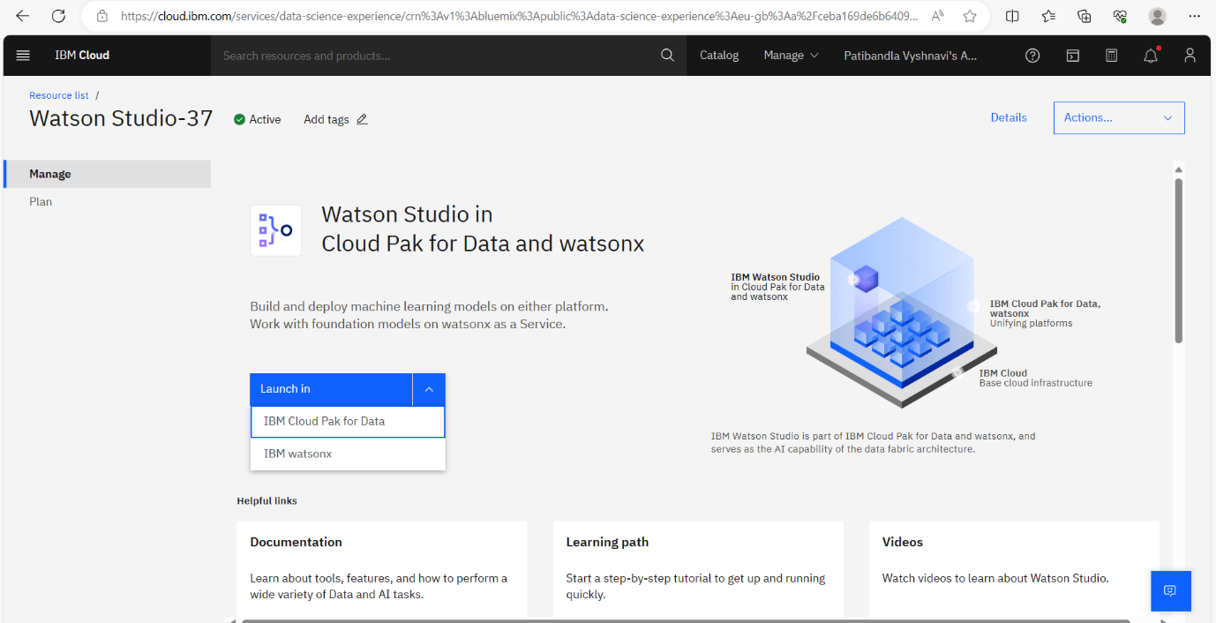

Step 4:

* After launching the IBM Cloud Pak for Data, it displays the below page then press the create new project
* It ask press next for the further process by press next it creates new project

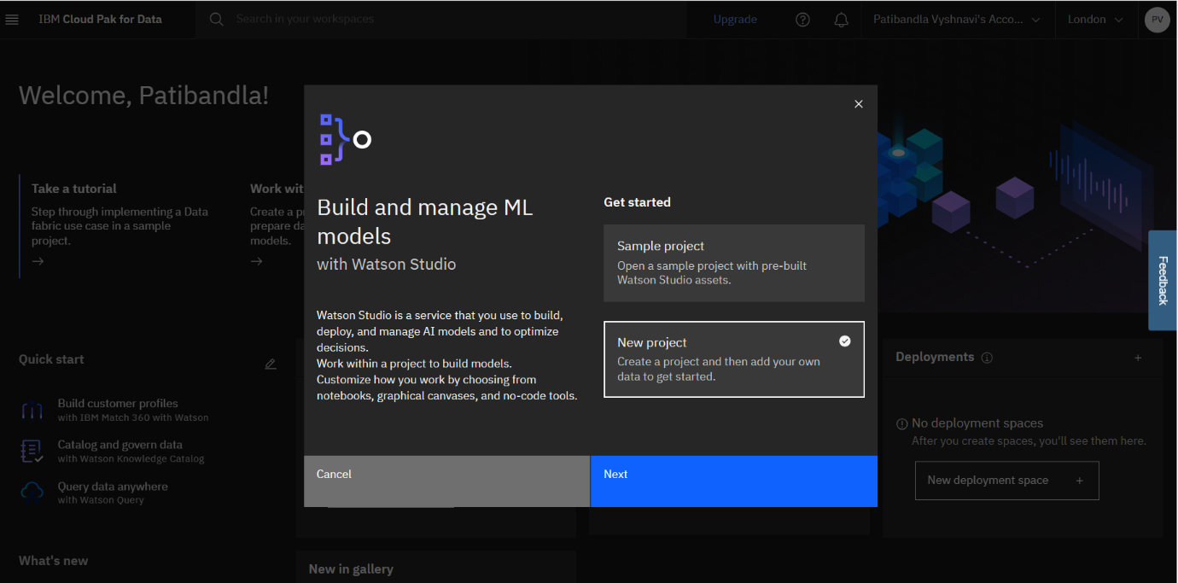

Step 5:

* It asks the project Name & Description to create a project, provide those to create a project

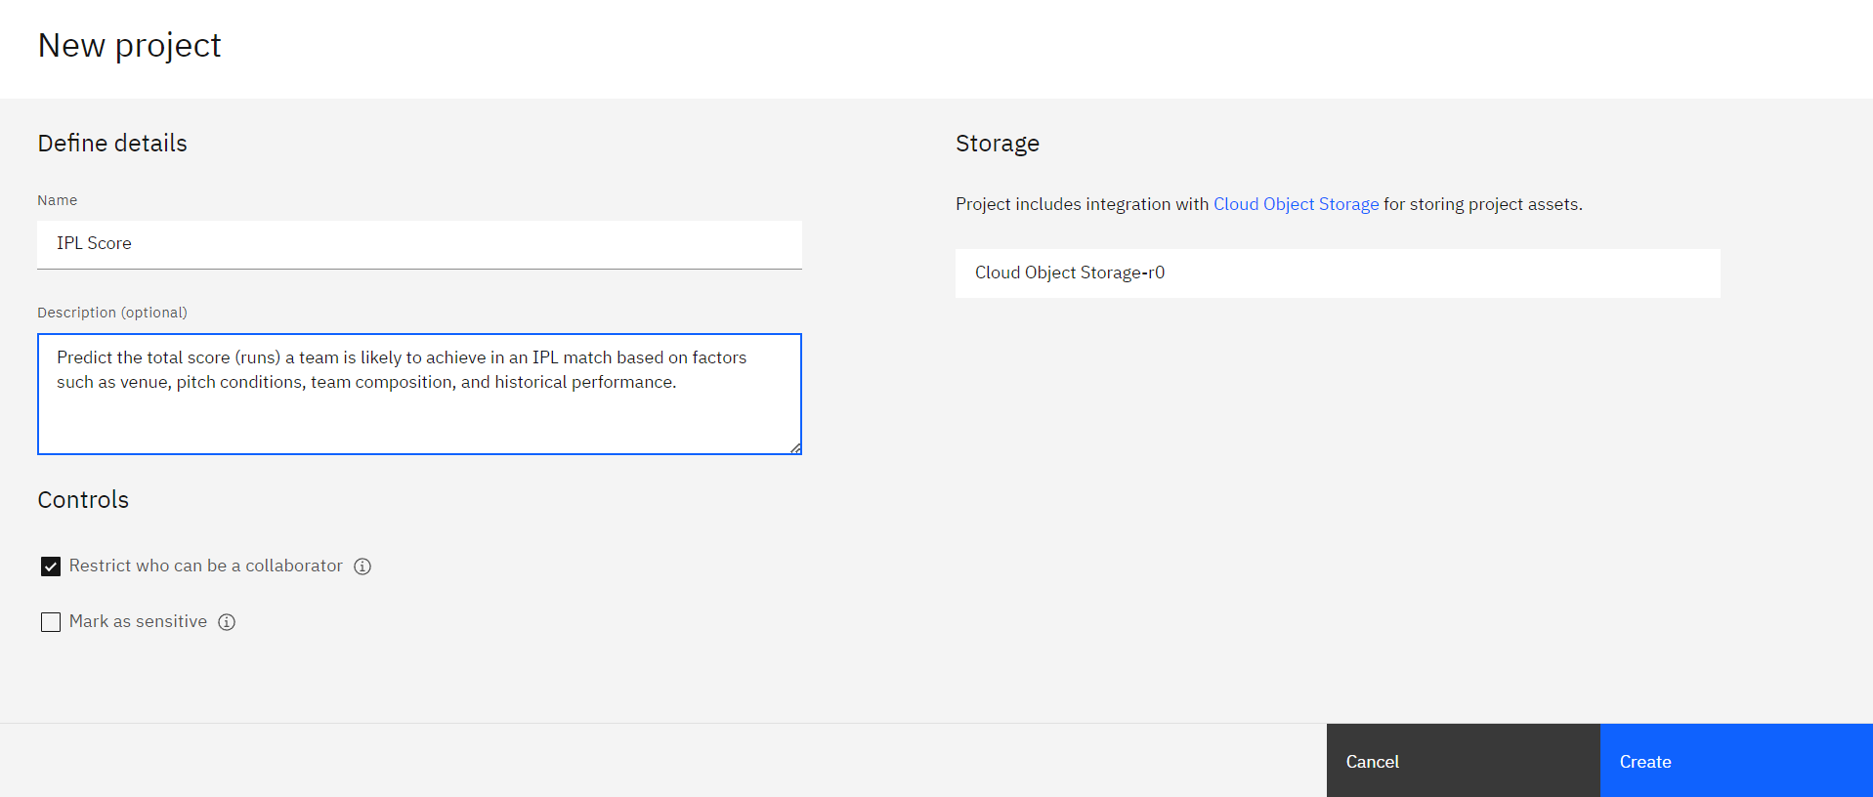

**Development Part 2**

In this part we are developing a ML model using Watson Studio and deploying into the IBM Cloud. This is continued into the step by step process from model developing onwards,

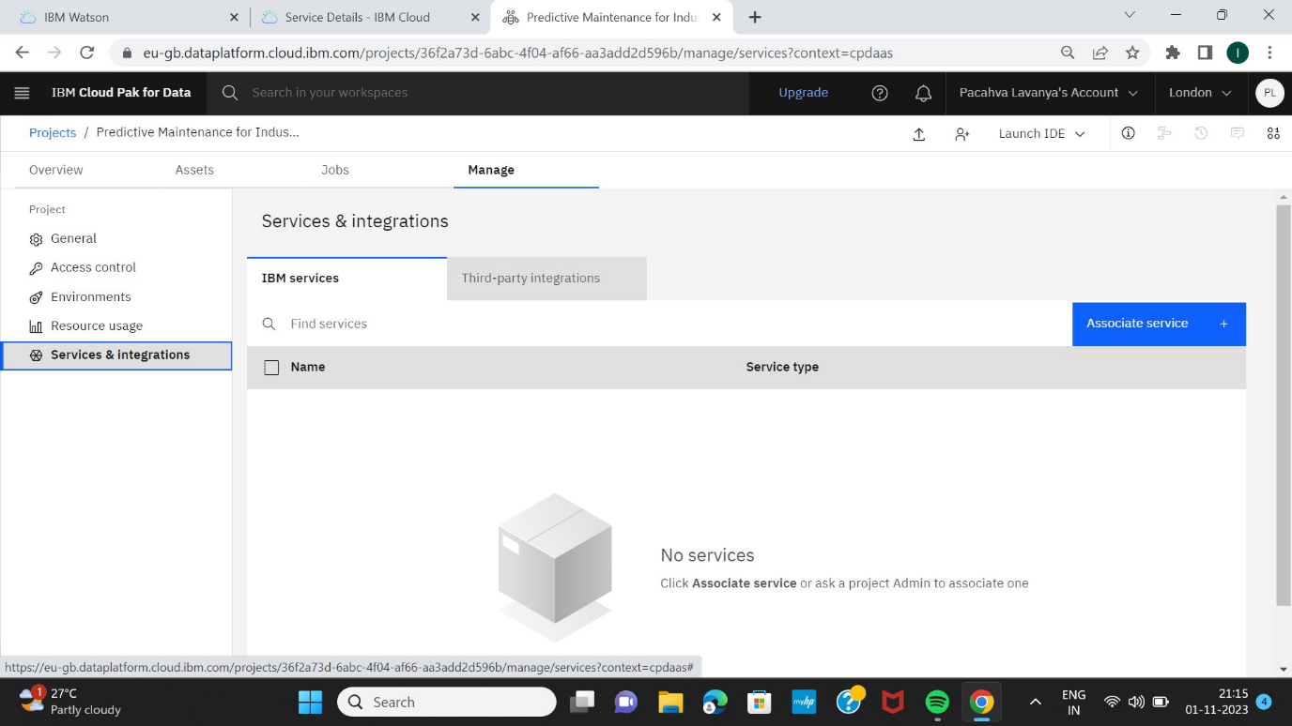

STEP 1:

From the above picture we can see that previously created project, now here we associating services which is previously existed.

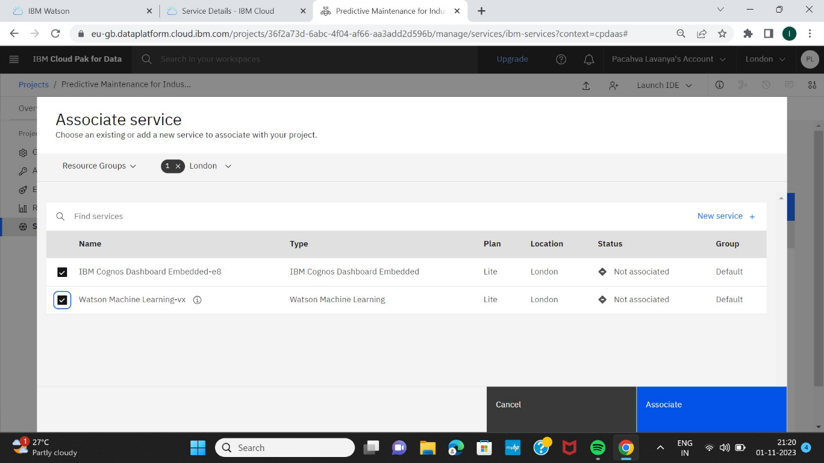

STEP 2:

It is process of creating model by New asset it displays like a below page from there we need select the Model

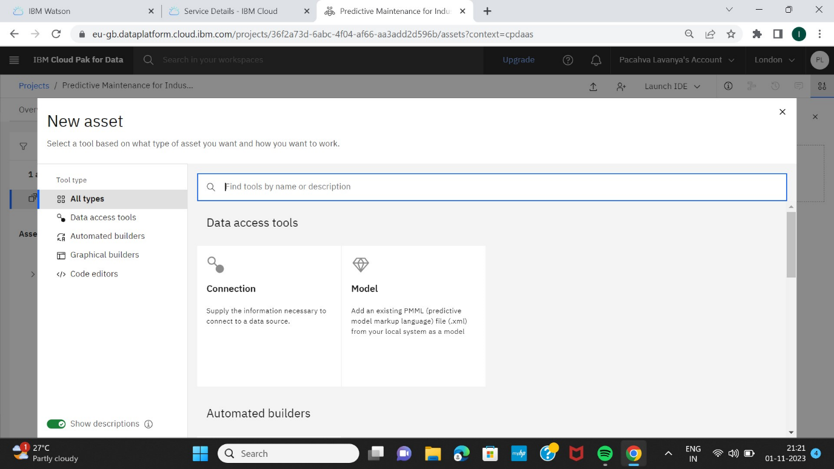

After pressing model it displays next page, Here we need to choose the Gallery sample

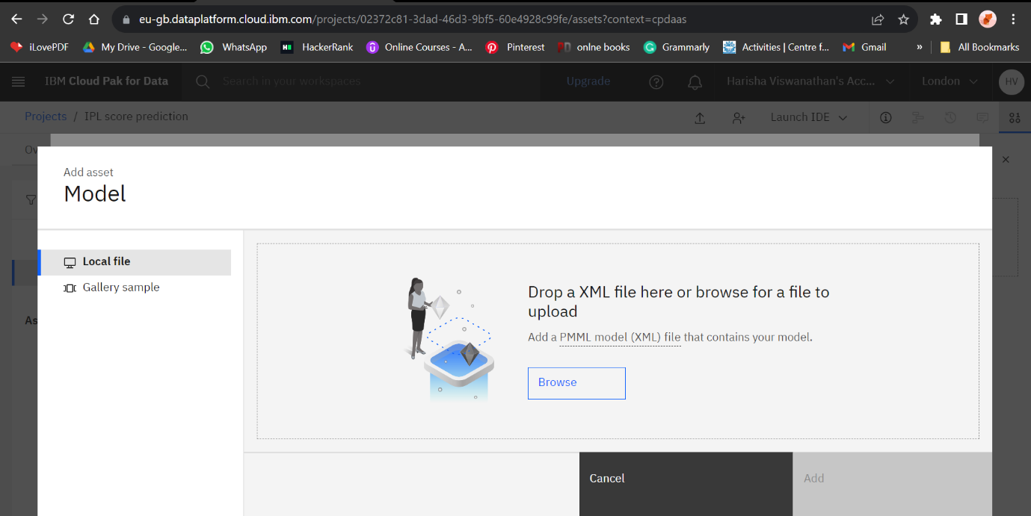

Next it gives two options in that we need to choose the credit Risk , Then press NEXT option for the further process

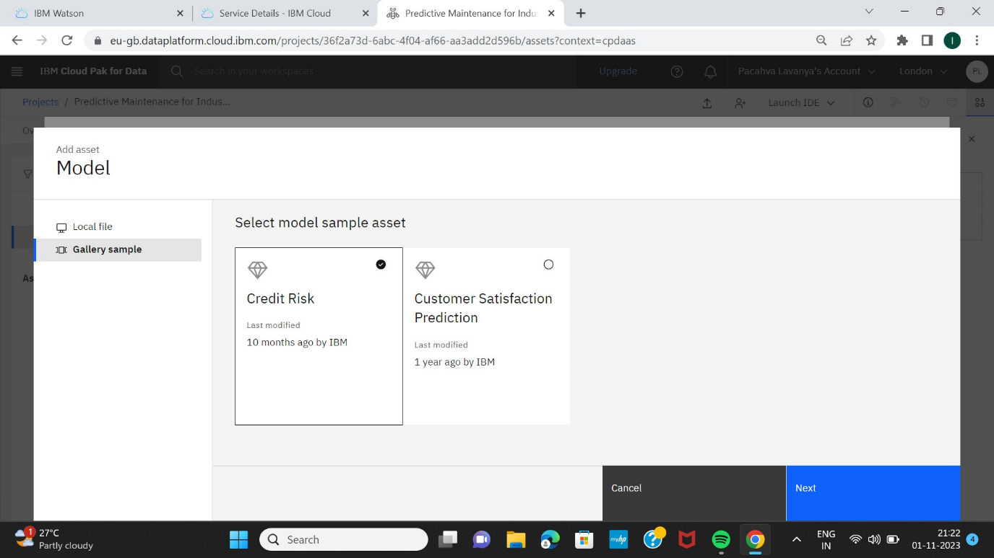

STEP 3:

It is the process of giving name of the model, here I am model as Credit Risk.

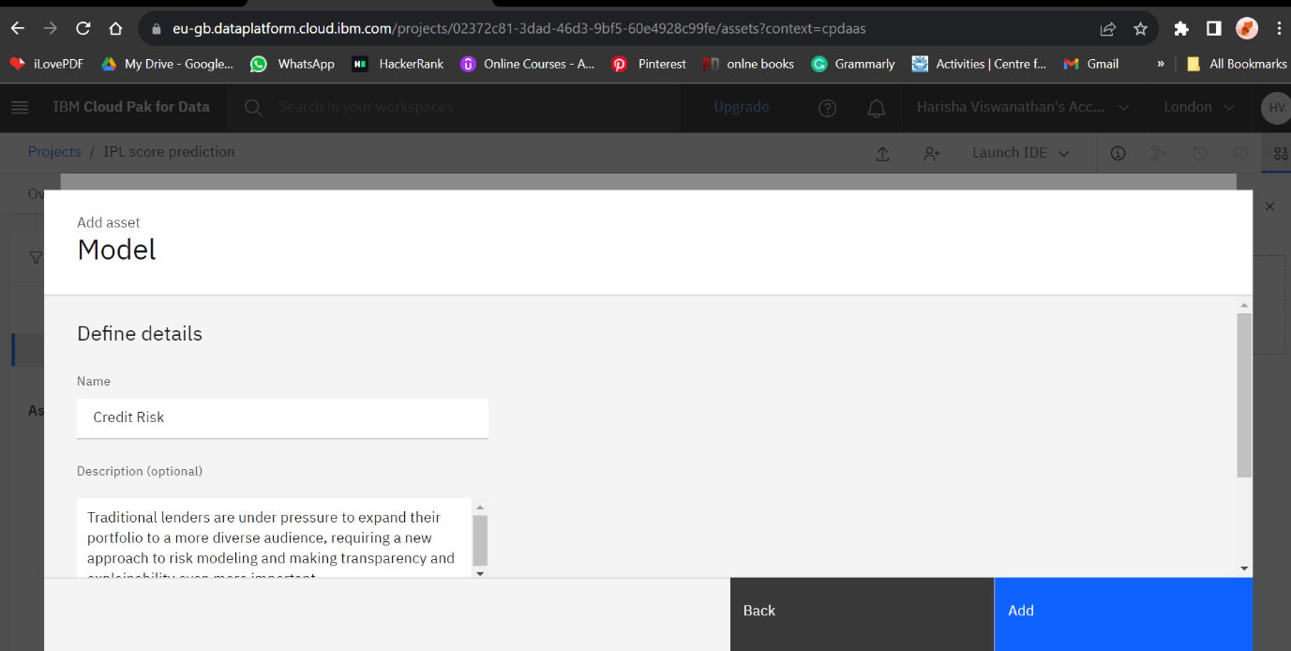

Then press the Add to move next process

STEP 4:

It is process of deploying the developed model, Here press the promote to deployment space

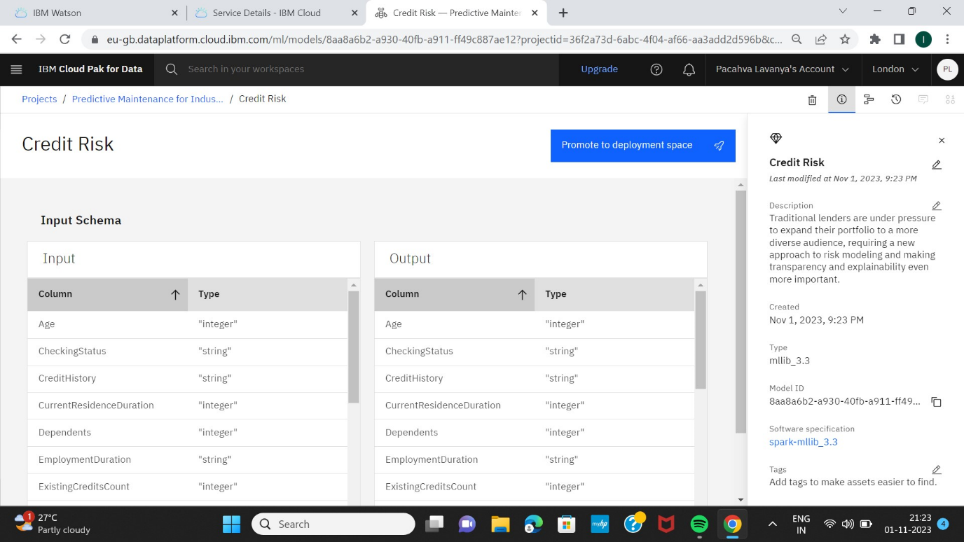

Now we need to Promote to space ,to promote space we need to create a target space. Then press promote

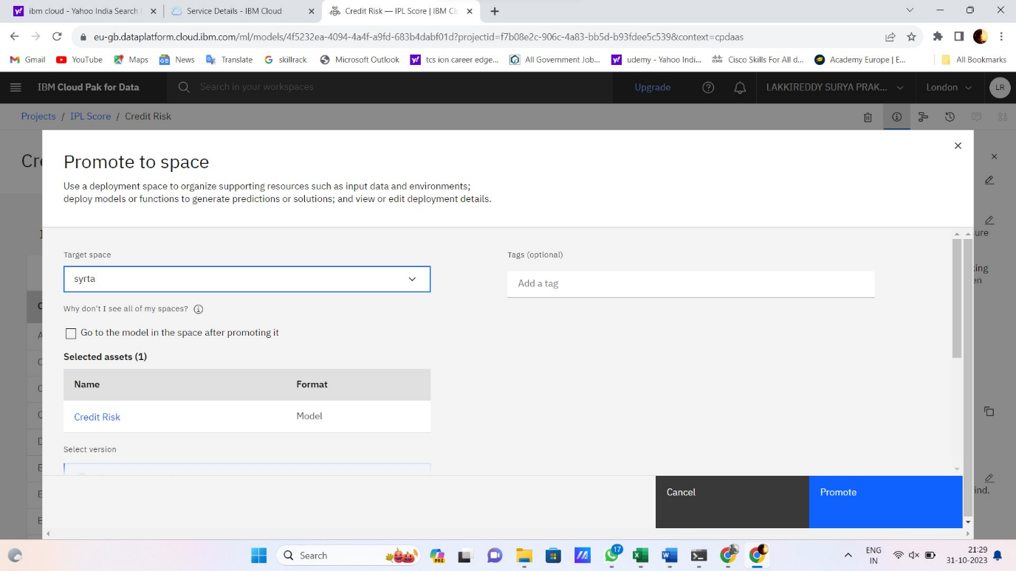

STEP 5:

Here we can see the list of models created using Watson Studio

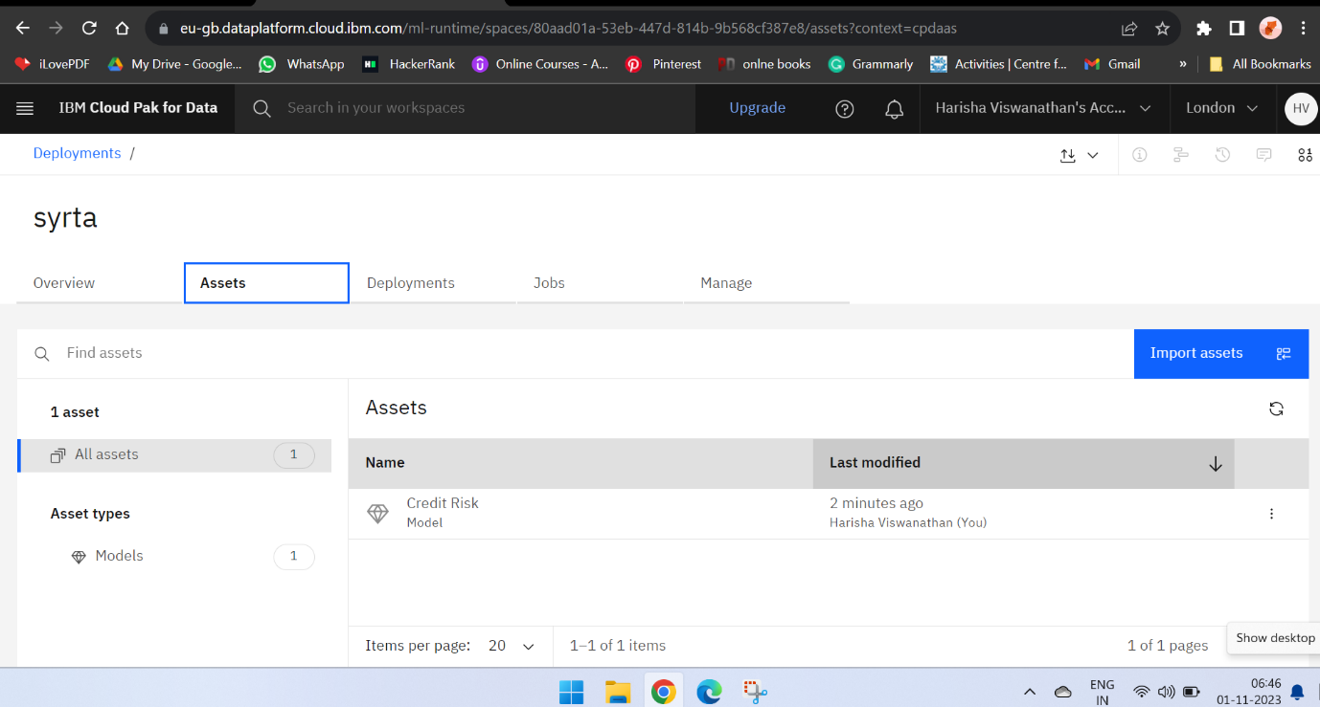

Now choose the developed model from the above list of models

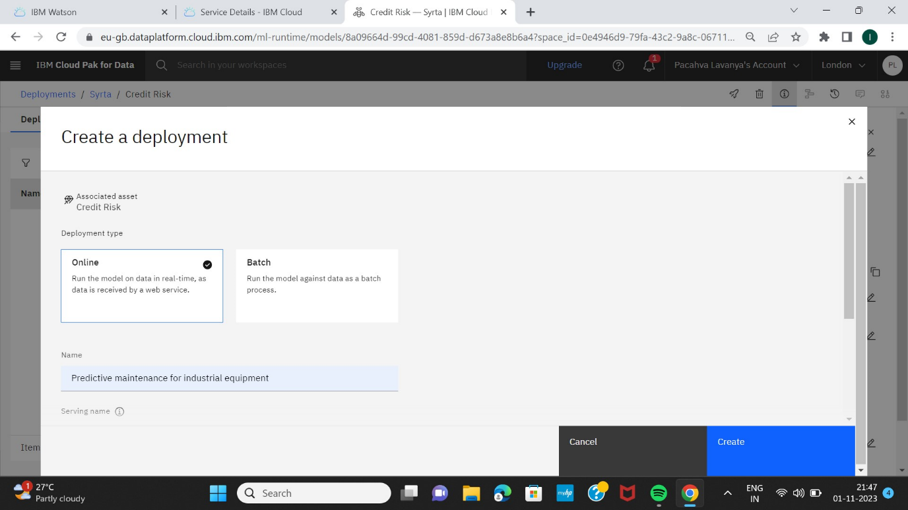

Choose as online to deployment the model and give the name of a model , then press the Create

STEP 6 :

It is the process of Initialising the Deployements of a model

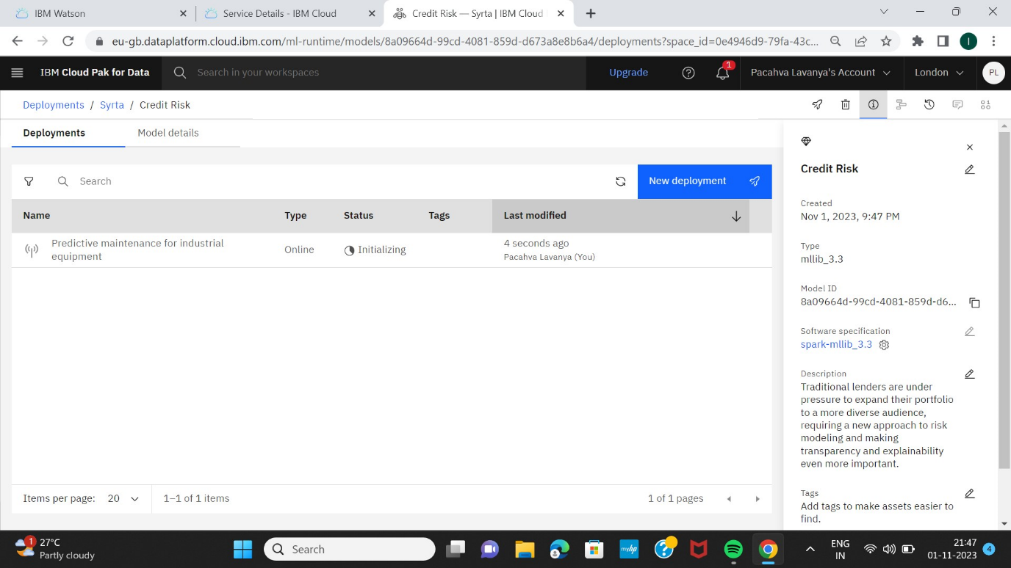

After Initialising the model



STEP 7:

It is the process of testing the model

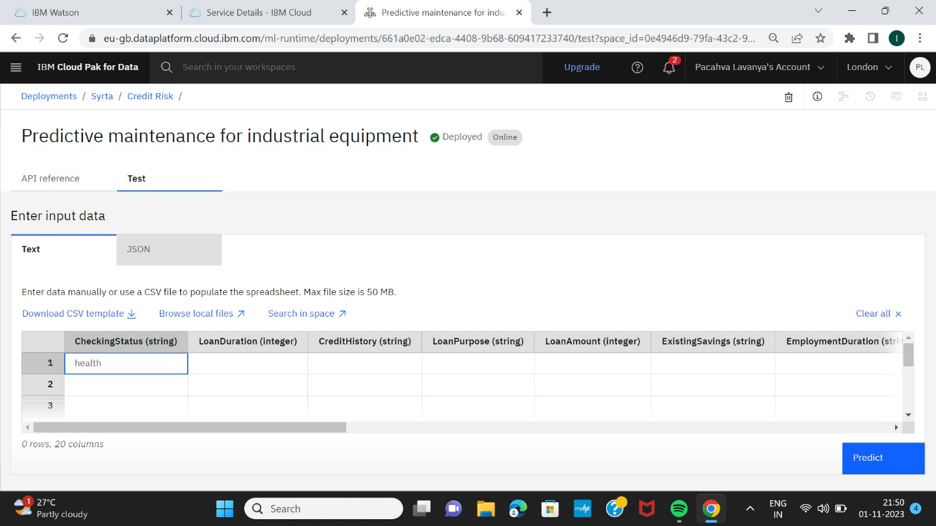

STEP 8:

The model is successfully deployed into the IBM Colud

